June 13, 2012


Traffic.511.org
TrafficLand Update Service

Version 1.0

Prepared by:
SAIC
David Balmer


1000 Broadway, Suite 680
Oakland, CA 94612

Table of Contents

1 Overview 3
1.1 TrafficLandService 3
1.2 TrafficLandTester 3
2 Deployment 4
2.1 Database Scripts 4
2.2 Service Installation Scripts 4
2.2.1 Install.bat 4
2.2.2 Uninstall.bat 4
3 Configuration 5
3.1 Service Config file (used by the windows service) 5
3.2 Updater Config file (used by the CameraUpdater, called by the windows service) 5
4 Testing and Debugging 6
4.1 TrafficLandTester 6
4.2 TrafficLandService 6
5 Sample HTML Report 7

Overview
This service is part of the “Additional Camera Sources” project, and requests the xml feed from TrafficLand to update tblCameraInfo used to display camera icons on the map.
SVN: http://vcs.lan.511.org/Repositories/TI_Prod/TI 511-Web/Camera Utilities/TrafficLandUpdate
The solution consists of two projects:

TrafficLandService
A windows service that requests the xml feed (defined in tblCameraSource) every 10 minutes. Results are generated in xml format and transformed into html using an embedded xslt stylesheet. The resulting html file is sent as an email attachment. The service config file contains the key to the tblCameraSource table, and the paths to TrafficCore and the updater config file.
If any errors are encountered, the html report is sent as an attachment to a configurable mail account.

TrafficLandTester
A console application that can test the update without installing the service.

Deployment

Database Scripts
The deployment folder contains a DBScripts/scripts.txt file with the required database updates.
- CREATE tblCameraSource
- ALTER tblCameras
- CREATE spGetCameraSource and spUpdateCameraInfo
- CREATE tblCameraSource rows and UPDATE existing tblCameras

Service Installation Scripts
The deployment folder also contains batch files that support command line parameters.

Install.bat
@echo off
set SERVICE_NAME=TrafficLandService
set SERVICE_EXE=TrafficLandService.exe
set SERVICE_HOME=C:\Traffic\TI 511-Web\Camera Utilities\TrafficLandUpdate\TrafficLandService\bin\Debug

REM The following directory is for .NET 4.0 on Windows XP
set INSTALL_UTIL_HOME=C:\WINDOWS\Microsoft.NET\Framework\v4.0.30319

REM Account credentials if the service uses a user account
REM set USER_NAME=<user account>
REM set USER_PASSWORD=<user password>

set PATH=%PATH%;%INSTALL_UTIL_HOME%

cd %SERVICE_HOME%

REM usage:
REM installutil /name=<service name> /account=<account type> /user=%USER_NAME% /password=%USER_PASSWORD% %SERVICE_EXE%

echo Installing Service...
installutil /name=%SERVICE_NAME% %SERVICE_EXE%
echo Done.

Uninstall.bat
@echo off
set SERVICE_NAME=TrafficLandService
set SERVICE_EXE=TrafficLandService.exe
set SERVICE_HOME=C:\Traffic\TI 511-Web\Camera Utilities\TrafficLandUpdate\TrafficLandService\bin\Debug

REM The following directory is for .NET 4.0 on Windows XP
set INSTALL_UTIL_HOME=C:\WINDOWS\Microsoft.NET\Framework\v4.0.30319

set PATH=%PATH%;%INSTALL_UTIL_HOME%

cd %SERVICE_HOME%

echo Uninstalling Service...
installutil /u /name=%SERVICE_NAME% %SERVICE_EXE%
echo Done.

Configuration

Service Config file (used by the windows service)
TrafficLandService.exe.config in the installation folder contains the following entries:
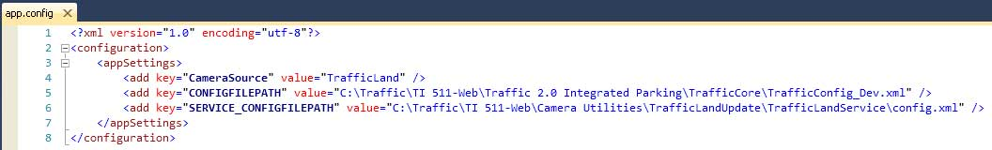

Updater Config file (used by the CameraUpdater, called by the windows service)
The location of this file is defined in the SERVICE_CONFIGFILEPATH above.
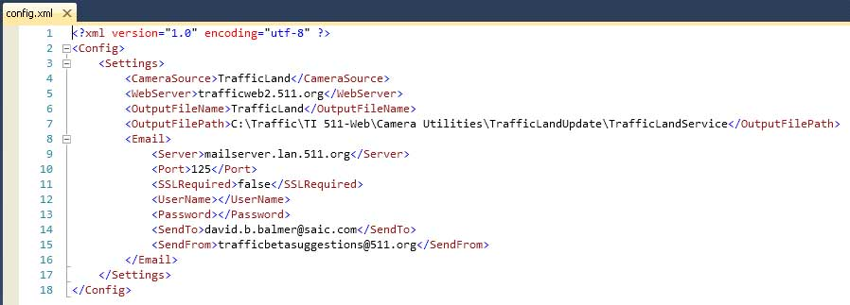

Testing and Debugging

TrafficLandTester
Modify Program.cs to pass the location of the updater config file:
static void Main(string[] args)
{
CameraServices service = new CameraServices();
CameraSource cameraSource = service.GetCameraSource("TrafficLand");

using (CameraUpdater cameraUpdater = new CameraUpdater())
{
cameraUpdater.Init(cameraSource, @"path to config.xml");
cameraUpdater.Start();
};
}

TrafficLandService
The easiest way I found to test the service, is to add a Debugger.Launch() call to Service.cs as below, which will be triggered when the service starts.
protected override void OnStart(string[] args)
{
TimerCallback callback = startCameraUpdater;

CameraServices service = new CameraServices();
CameraSource cameraSource = service.GetCameraSource(ConfigurationManager.AppSettings["CameraSource"]);

int timerInterval = cameraSource.FeedInterval;

Debugger.Launch();

cameraUpdater = new CameraUpdater();
cameraUpdater.Init(cameraSource, ConfigurationManager.AppSettings["SERVICE_CONFIGFILEPATH"]);
timer = new Timer(callback, null, 1000, timerInterval);
}

Sample HTML Report

